**Gracious Germents**

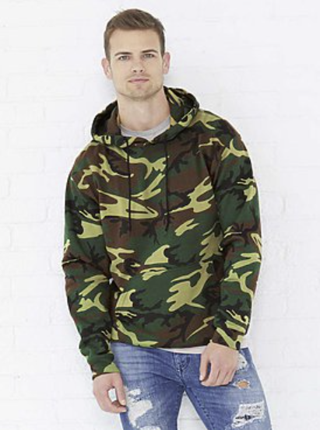

**DESCRIPTION:**

Code Five™ Adult Camouflage Fleece Long Sleeve Pullover Hooded Sweatshirt with Drawstring

The perfect camo for your lifestyle. Whether playing hard or just relaxing, you need a hoodie that can handle everything life throws your way. From the fields to the forests and all of the journeys in between, Code Five is with you every step of the way.

Fabrication: 7.5 oz. 60/40 cotton/polyester printed fleece • Urban Woodland is sewn with 100% cotton thread

Features: Fleece lined hood with solid color drawstring • Coverstitched hood, neck, shoulders and armholes • Coverstitched 2″” 1×1 ribbed cuffs and bottom band • Coverstitched front pouch pocket • Side seam construction • EasyTear™ label

Care: Machine washable/ tumble dry low

Note: Bleed resistant ink is recommended when printing our camouflage products

Fit: Adult Unisex – True to Size

2% of all Code Five™ sales are donated to Children of Fallen Soldiers Relief Fund, Inc. and Fisher House™.

**ADDITIONAL INFORMATION**

Weight: 0.5 kg

Dimensions: 10 × 8 × 3 cm

Size: S, M, L, XL, 2XL, 3XL

Price: $30.00